Dialectical Storytelling and Antenarrative Analysis
David M. Boje, Ph.D.
May 13th, 2016
Prepared for Copenhagen Business School Ph.D. Course “Narrative Approaches for Organizational and Communication Research” 17-20 May 2016

Abstract
Hegel’s dialectic is not the thesis-antithesis-synthesis model attributed to him by too many scholars. Rather, the dialectic is constituted as a process of movement, in which there is an “interfustion of being and action” (Hegel, 1807: 401). The purpose is to develop a dialectical method, theory, and practice of storytelling, called ‘dialectical storytelling.’ It has the advantage of grounding the dialectic in action as well as contingency as the storytelling unfolds in context, in space, in time, and in material conditions. There are four contributions intended by dialectical storytelling. The first contribution is to move beyond retrospective sensemaking as a way of knowing (epistemic) to its more ontological aspects. In particular, the sensemaking dialectic is process of selecting remembering and forgetting. The second contribution is to move beyond individual sensemaking to the dialectic of being-for-self and being-for-another. This includes the Notion of organic elasticity of the movement of this dialectic. Elasticity in storytelling relations of self and other, is how the form of the telling returns to selfsameness (like a stretched rubber band that returns upon release to its former shape). The third contribution is called Reproduction Introflective Dialectic. Introflective is a special reflexivity on the plight of species, its Being-ness in the world. Hegel’s introflective concept has yet to be applied to storytelling, much less to organization studies. The final contribution is to examine the school of wisdom, as a return to what Cajete (2000) calls Native Science, how humans can learn form Nature. This would involve a posthumanist counternarrative to the usual human-centric narrative. As a pedagogic device, the four aspects of dialectical storytelling are demonstrated in the case of how a southwestern U.S. university has been reacting to a pair of Swainson’s Hawk that has been attempting for three years to breed, hatch, and successfully care for its fledglings. As such it is also an autoethnographic kind of storytelling, since it is my own university.

PART I: Dialectic Storytelling Method and Theory

In Boje (2008) I began to work out a dialectical option to dialogical storytelling. Here, my purpose is to develop Hegel’s dialectical approach and apply it to storytelling methods, theory, and practice.

Dialectical Storytelling is a methodology for tracing the movement of many contradictions. It has four phases: Sensemaking Fluidity, Self-Other Elasticity, Reproduction, and Search for Wisdom.

- Sensemaking Fluidity Dialectic (aka Sense-Certainty) This is what Weick calls retrospective sensemaking and Hegel calls sense-certainty, but stresses its universal fluidity (Hegel, 1807: 3266). Both Weick and Hegel are about the five senses as they sort out a Here, in relation to other Heres, this Now in relation to other Nows, this 'I' an observing consciousness in relation to other 'I's' also observing. Hegel is much more about the ontology of 'movement' as the observing consciousness of the sensemaker enacts a process of selective remembering and forgetting. These multiplicities of relationships of 'movement' in the 'dialectic of sensemaking' of Heres, Nows, and I's has a fluidity of movement that is core to the sensemaking dialectic of storytelling. The fluidity involved is that a particular Here, Now, and 'I' are in dialectic relation to the context of others Heres, Nows, and other I's. Some Here-Now-I is experienced first-hand, or directly. However, in storytelling, a plurality of Heres, Nows, and I's are second-hand, or even third-hand, yet blend in wiht what one directly experiences. In addition the sensemaker is forgetting (Hegel, 1807: #109) what was directly experienced, and what others related as their own experience, which in turn is the negation of negation, the forgetting of experience, as more experience occurs. Hegel's purpose is to go beyond sensemaking, to deeper and wider kinds of awareness. In the case of Human-Hawk-Habitat (3H), the Human is dimly aware of the Hawk, as a nuisance, as dive-bombing the unaware student walking blindly about Nature staring at thier cell-phone screen (or at the ground), or with ear-buds listening to music, rather than hearing the 'Kearrrr' Hawk's alarm sound when Human gets too close to prey (food source), or to (egg), or to hatched (fledgling). Ironically, the Swainson's Hawk never seems to dive-bomb or 'swoop' at the workers deconstrucing the nest, destroying the heart of the nest (see above photos).
- Self-Other Elasticity Dialectic Hegel's key concept is organic elasticity, the return of variations to a selfsameness [fractal] pattern. In storytelling, the being-for-self and the being-for-other come into a dialectic, and more negation of negations. Hegel (# 266) terms this phase, Itrritability, the reaction of I and Other to one another, or being-for-self in dialectic to being-for-another. There are two wider domains of awareness beyond sensemaking, and beyond the Self-Other Elasticity Dialectic. Students on cell-phones walking blindly about Nature, and faculty seen swinging a broom handle at fledgling, is all about being-for-self, and is dialectically opposed to being-for-another, in this case the Hawks, and their Fledglings. The University is being-for-self, in its narrative about avoiding the possibility of a lawsuit, brought by student (or parents), and is therefore, having the grounds crew deconstruct the nest. Meanwhile at University of Pittsburgh, Cornell Univesity, and other universities, there is no war between Humans and Hawks, no deconstruction of nests, but rather anticipation over the newly laid eggs, the birth of fledgling greeting by positive regard, or being-for-another-species. It is the difference between Humanist, and Posthumanist ontology. There are two even wider awarenesses.

- Reproduction Introflected Dialectic Introflected, is a wider aspect of sensemaking awareness, of the whole, of self-preservations of the species, of ones dialectical role in bringing forth individual that keep the species in its movement.

"Reproduction, however, is the action of the whole individual. Reproduction, taken in the sense of self-preservation in general, expresses the formal Notion of the organisim, or sensibility [aka sensemaking]; but it is, strictly speaking, the real organic Notion or the whole, which returns into itself, either qua individual by producing single parts of itself, or quaa individual by producing single parts of itself, or qua genus, by bringing forth individuals" (Hegel, 1807: #266, bracketed addition, mine). In our case study of NMSU and Hawk co-existence, the Swainson's Hawk pair are attempting to bring forth individual fledglings, producing eggs in a carefully constructed nest, in a tree in which they were born, and this is an act of self-preservation, in general of its species.

- The School of Wisdom Wisdom is mentioned 24 times in Hegel's (1807)Phenomenology of Spirit. Spirit means Reason, and this phase of Reasoning Spirit, is something Humans can learn in a School of Wisdom. Hegel gives the example of the ancient Eleusinian Mysteries of Ceres and Bacchus:

“In this respect we can tell those who assert the truth and certainty of the reality of sense-objects that they should go back to the most elementary school of wisdom, viz. the ancient Eleusinian Mysteries of Ceres and Bacchus, and that they have still to learn the secret meaning of “the eating of bread and the drinking of wine. For he who is initiated into these Mysteries not only comes to doubt the being of sensuous things, but to despair of it; in part he brings about the nothingness of such things himself in his dealings with them, and in part he sees them reduce themselves to nothingness. Even the animals are not shut out from this wisdom but, on the contrary, show themselves to be most profoundly initiated into it; for they do not just stand idly in front of sensuous things as if these possessed intrinsic being, but, despairing of their reality, and completely assured of their nothingness, they fall to without ceremony and eat them up. And all Nature, like the animals, celebrates these open Mysteries which teach the truth about sensuous things” (Hegel, 1807: #109).

Initiations into the School of Wisdom was held in the city Eleusis, in old Aggie culture of ancient Greece, dating back to the Mycenean period (c. 1600 – 1100 BC). The Mysteries of the School of Wisdom, were to honor Ceres (Demeter, Rhea, or Isis), her daughter (Persephone), and Dionysis. It includes the myth concerning Demeter, a goddess of agriculture and fertility, and was recounted in one of the Homeric Hymns (c. 650 BC). The initiates learned Nature's most sacred secrets. For Hegel, animals are not shut out form wisdom, and celebrate these open Mysteries of what lies beyond sensemaking and Self-Other dialectics, and beyond Introflective dialectic.

Next, I will work out the Antenarrative Theory aspects of a dialectical approach.

PART II: ANTENARRATIVE THEORY

Antenarrative Theory (Boje, 2001, 2008, 2011, 2014) has gone through many changes and has developed. Initial work looked at ante as the before-narrative coherence, and as the prospective sensemaking ‘bets’ on the future. The more recent work, in particular with Marita Svane makes, connections between Heidegger (1962) and antenarrative aspects. Heidegger develops fore-having, fore-conception, fore-structure, fore-telling, and we add the Notion of fore-care. We connect Heidegger’s concepts to the before, beneath, between, bets, and becoming --- that we see as happening all around and through living story webs and dominant narratives and counternarratives.

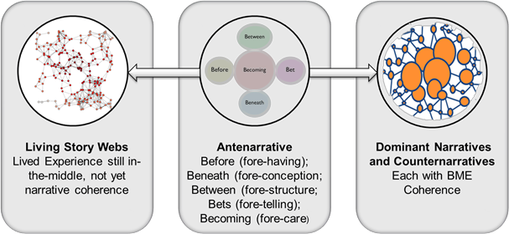
Drawing of Antenarrative relations by Marita Svane (see Boje, Svane, Henderson & Streval, in press; Svane & Boje, 2014; Svane & Boje, 2015; Svane, Boje & Gergerich (2015).

What I want to do here is show how Heidegger’s Being and Time, as an unfinished project, in part, was about a critique of Hegel’s dialectic, and his approach to the ontology of Being, and to temporality. Indeed the last section of Heidegger’s book is devoted to developing a dialectic that moves beyond Hegel.

The opportunity here is a different kind of antenarrative, one of fore-caring (becoming) can emerge, if NMSU learns from its errant Hawk-care experiment, and the sciences of all six colleges, produce different experiments, on the relationship between Hawk-Human-Habitat.
All species of hawks are protected under the Migratory Bird Treaty Act and it is illegal to harm, harass or kill them.
—I'd sure say NMSU is harassing two hawks -- and arguably harming them.
- My own position is that what NMSU is doing is legal, but has been given an exception.

"It also appears that NMSU has contacted FWS about a permit to do more. That would likely involve moving the hawks, which would be done by an expert, not by NMSU itself; and it could even allow NMSU to kill the hawks, although NMSU's Tom Dobson told me Friday afternoon that "destroying the birds is not an option that we're even pursuing.”

From Hegel's Phenomenology of Mind is what Žižek calls a Hegelian joke:
"The "depth" which mind brings out from within, but carries no further than to make it a presentation (Vorstellung), and let it remain at this level−−and the "ignorance" on the part of this consciousness as to what it really says, are the same kind of connection of higher and lower which, in the case of the living being, nature naively expresses when it combines the organ of its highest fulfillment, the organ of generation, with the organ of urination. The infinite judgment qua infinite would be the fulfillment of life that comprehends itself, while the consciousness of the infinite judgment that remains at the level of presentation corresponds to urination."
And from Hegel (1807: section # 346) Phenomenology of Spirit:
“ As long as we look on them as sundered, their opposition remains gross and crass: it is like the union of urination and orgasm in a single organ.”
Let us hope it does not come to that End, that fore-having action, the move from destroying nests, destroying life possibility of fledgling, and the reproduction of the Swainson Mama and Papa Hawk pair, their fledgling eggs without nest.

PART III: THE CASE STUDY OF STORYTELLING DIALECTICAL METHOD

There is a Here and Now mystery, as well, of the annual migration of the Swainson's Hawk pair, from Argentina, a 7,000 mile journey, to a Nesting Tree, in the heart of the New Mexico State University campus.

I propose NMSU adopt the Swainson's Hawk as its Logo
(Drawing by D. Boje, used by Permission)
At University of Pittsburgh, is a webcam atop the Cathederal of Learning, a raptor 4/30/2016 has just laid her egg, but here at NMSU there is no webcam, co celebration of learning. AtCornell University, a webcam a top a pole above the football stadium. Now compare what New Mexico State University is doing to its Swainson's Hawk's, but without a webcam:
VIDEO Trailer: One Minute Intro to the Situation of Swainson's Hawk at NMSU:
1:07

Can Hawk and Human Coexist at New Mexico State University
David Boje Ph.D. Regents Professor, at NMSU did camera in above film
I want to find a way for Hawk and Human to Live in Peace in their Shared Habitat. The Swainson Hawk pair journey 7000 miles...
Swainson's hawk (Buteo Swainson), was named after William Swainson, a British naturalism aka grasshopper hawk or locust hawk, as it is very fond of Acrididae (locusts and grasshoppers) and will voraciously eat these insects whenever they are available (More at Wikipedia).

May 2 2016 Photo of Fallen and Broken Swainson's Hawk Egg, 'Before' the Heart of Nest could be completed by D. M. Boje (used by permission)

The nest over that weekend (April 29 to May 1st) was about 70% completed, only the center of the nest (below) was not yet constructed by Mama and Papa Swainson's Hawk, but the egg apparently was laid too early (the nest itself was removed on May 2nd, when 'I' was in the 'Here' and this 'Now' to film the 'Mattering' of the Egg. On May 3rd, I turned the Fallen Egg over to New Mexico Fish and Wildlife Official for further study.
Next, I filmed an almost successful nest attempt.
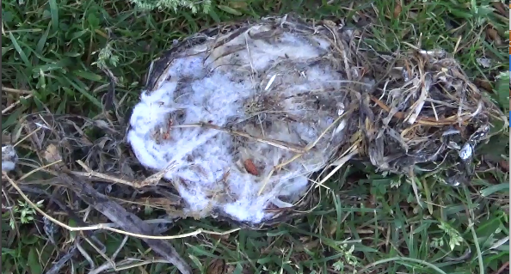
May 9 2016 Photo of Fallen Swainson's Hawk Nest by D. M. Boje (used by permission)

My 'I' observes a 'Here' and 'Now', the heart of the Swainson's Hawk Nest that actually fell to the ground as once again the University deconstructed the nest site, expecting the Hawk pair to move further away from the heart of the NMSU campus. The Nest fits in the plam of my hand. It is composed of fine cotton fibers collected by the Swainson's pair, in preparation for 2 to 4 eggs. Once the eggs stay in the nest, in the tree, in a Here and Now that is not yet happened in 2016, then the Federal Law called the Migratory Bird Treaty, takes over, and the University, its grounds crew, its subcontractor crew, and so, may not disturb the nest, its eggs, and the fledglings will be protected. See May 9 2016 VIDEO https://www.youtube.com/watch?v=qyWunpj1OyM

Swainson's Hawk is listed on the endangered species listhttp://www.dfg.ca.gov/wildlife/nongame/t_e_spp/bird.html

Friday May 6th, 2016, a Swainson's Hawk couple moved their nest site from Renfrow Gym to a tree much closer to the heart of NMSU, and once again on May 9th, 2016 the University cut down the pair's nest. QUESTION: Is this strategy by NMSU the definition of Insanity?
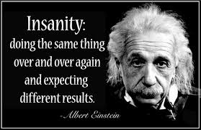

As Hegel (1807: #108) puts it "The Here, which was supposed to have been, pointed out, vanishes in other Heres, but these likewise vanish." In other words, the Egg surviving in the Nest, and hatching a Fledgling is a Here that was supposed to have been, but instead a plurality of other Hares happened, and these too shall vanish. What I point out in Dialectical Storytelling, is the Fledgling that would have been is a negation, brought about by thenegation of several prior negations: the Egg, the Nest, the Branches which supported the Egg and Nest, and so on.

After 50,000 years of Human and Hawk species co-existence, what is it about these past several years, that is as Derrida puts it, out of joint? I hazard an abduction, that the more than the usual construction has been happening the past 3 years, with the new Dominici building, the new photovoltaic parking structures, the rennovation of Renfrow Gym, and renovation of Engineering I building, with its fauclty staying in the temporary offices at Regents Row, and so on. Maybe Human is unaware of his the noise and chaos of building construction affects the peace and serenity of the Hawk. Once upon a time, the NMSU campus was an inviting Habitat to the Hawk pair, and Humans paid them no nevermind. Why 'Here', why this particular 'Now' why 'I' among all the Heres, Nows, and I's. Not just the "I" of indifference, or the "I" of concern over litigation, but also the "I" of the grounds crew, a few faculty, who stare at the Mystery of Nature, and see a tragic loss of opportunity.

Watch Video of New Mexico State University Workers About to take away the established Swainson Hawk pair's Nest and Duck Tape a Traffic Cone in its Place You can see the Nest, about center of the scene, Hawk entering from the Right, This Attack by the University on the Hawks and their Nest occurs every morning at the University between 7AM and 8AM.
You can hear the NMSU workers say at end of the film joking about the destruction
NMSU Worker 1 "Yah they're back"
Professor Carol Campbell" "youu whoo , hickkeee hicckee They both got sticks" [Note: the sticks are in the beaks of Mama and Papa Swainson Hawk, who have been hard at work building their nest for 24 hours, day and night]
NMSU Worker 1: "Yah you got both of them, the male and the female here."
NMSU Worker 2: "Here she comes"
NMSU Worker 1: "Is that little bird positive?"
NMSU Worker 2: "Yah" [Chuckling]
NMSU Worker 1: ""That little bird knows in about three seconds it could be lunch [laughing]
NMSU Workers 2: [Chuckling] "I don't know, I think it thinks we are on his side?"
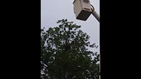

Annotated Picutre of the Interaction of 2 NMSU Grounds Workers with machine, about to the Destroy Swainson Hawk Nest in Mulberry Tree, while a Faculty Scientist takes the Picture with Her Cellphone, Mama Swainson Hawk and We Readers/Observers Engage in our own Sensemaking Storytelling of the Scene (Image by D. M. Boje, used by Permission)
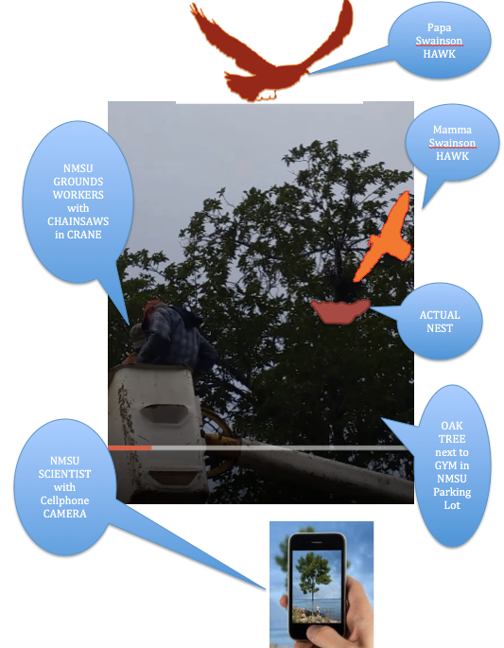
Drawing of Actual Nest and Mama Swainson’s Hawk, as Papa Swainson circles above watching the Attack by the University Workers on their latest Nest, as the Fledgling (not shown) will Not be born at NMSU in 2016 - Annotated Drawing by D. M. Boje, used by permission

In this image, I try to show the destruction by the University of this Swainson Hawk pair's nest, as Mama Swainson is driven away, and Papa Swainson circles above, and the position of the Research Scientist taking the Picture. As the Nest is taken away, no place for the Eggs to be in the Mulberry Tree. More at http://davidboje.com/hawk This is an instance of a Dialectic, the antithesis of Reproductive instinct of Organic Nature coming into Opposition with New Mexico State University's resistance to an Interspecies sharing of Habitat. Yet, in Las Cruces 5 other Swainson Hawk pairs are reportedly nesting, without any Swooping, Dive-bombing incidents. Why not at a Land-Grant Mission Aggie University, a Research University, which seems to have lost its way.

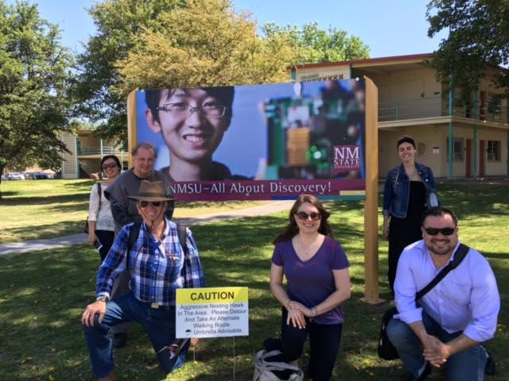
NMSU Storytelling Consulting Seminar (Mgt 685), on walking tour to see the battle between NMSU and Hawk over Habitat (April 25 2016)
This sign says to carry and Umbrella. April showers bring May flowers, so it’s best to be prepared with a brand new umbrella. Corbett Center Student Union invites NMSU students for this month’s “Crafts at Corbett” event held 6 p.m. Thursday, April 28, in the Aggie Lounge. Corbett Center will provide the materials. You provide the creativity! This event is free to students, while supplies last. Student Aggie ID will be required to participate. Click “going” or “interested” at facebook.com/events/1762018537352776/ for a Facebook reminder.

Slavoj Žižek (2014) "Is It Still Possible To Be A Hegelian Today?"
The excesses of unsustainability at NMSU undermine the Hawk’s survival; Every project to contain/control the Hawk is undermined by its inconsistency, its lack of Science. – from Žižek.
Slavoj Žižek says Adorno's rejection of Hegel's historical approach, asks if Hegel is still a living presence, our contemporary world in the eyes of Hegel. I will give some summary of Žižek: The anti-Hegelian argument is that something changed after Hegel, and a new era of thought was born, the rupture of the new era. Hegel stood between the mysticism of Kant and the mathematized natural sciences of empiricism that Adorno and Marx dialectic prefer. The emerging Hegelian dialectic strategy of the post-Hegelians is to ignore Hegel's ontological commitment, Hegel reduced reduced to general theories of discourse, or to the stupid and inaccurate rendition of Hegel to a naive thesis-antithesis-synthesis model that Hegel (1807) never advocated, and wrote against. We can now read Hegel dialectic as a break from pre-Hegelian metaphysics, and the post-Hegelian social constructivism or the empiricism of mathematical sciences Marx sought. Hegel from Jamison is a vanishing mediator between the pre and post.
To act as a Hegelian today does not have to be the 'deflated Hegel' and its fantasy-formation in epistemic (social constructivist or hyper-empiricism) images of Hegel' but rather can be an ontological standpoint. The emerging Hegelian ontological standpoint, is that it fills in this gap about the big questions: such as what is the relation of organic Nature and inorganic Nature of our cell phone escapism form living in the organic. Can there be a mediator between the two, the organic Nature and our inorganic Nature.
An ominous spectre of voice, the signs at NMSU, is a kind of foreign body intruder on the NMSU campus, that is beneath the systems action. Žižek's approach to Hegel ontological philosophy raises questions about our Beingness in the world, where we co-habit (air, water, earth, zones, & climate) the universal elements. This does not mean Hegel is looking for the hidden harmony of the organic whole of Nature, but rather is raising critical questions about the need to include in all of its systems, its inorganic antagonisms, the consequences of its relations and actions, its inconsistencies, its excesses, as each integral part of the whole is self-contradictory and antagonistic. For Hegel, Systems-->Science is the whole plus its symptoms, its unintended consequences which betray its untruth (e.g. speak about Aggressive Hawk, but not about the Aggression of Global Capitalism, & its abstract harmonious goal, & excesses that betray its End).
Things seem to be going wrong at NMSU, and we cannot find some hidden higher purpose. For Hegel dialectics, for every project such as this destruction of Hawk nests and branches, something will eventually go wrong. The destruction of Hawk nests in 2016 is an immanent consequence of the removal of nesting trees, nesting branches in 2015, and 2014, the expansion of building projects at NMSU, and the increase of agribusiness which reduced nesting sites around the State. Can NMSU take a more scientific and moderate path? Only the 'abstract terror' of 'Aggressive Hawk' or in the media 'Angry Bird' (named after the video game, creates the legitimating retrospective narrative for the annual removal of Hawk nests on campus, before the eggs are lain.
If we put this in the terms of Science and Systems choices of a Research University, a Land-Grant University, then we can say that NMSU's first choice has to be its own wrong choice, removal of nests from mating pair of Hawks. But as Slavoj Žižek puts it, it is" only the wrong choice that creates the conditions for the right choice." When we criticize the terror of the signage as reducing Swainson Hawk pair and fledgling to the abstract conception of 'Angry Bird' as against the freedom of the Hawk to do what it has done for many centuries: to nest, to breed, to raise fledgling to fear Human aggression. 'No' this is not Hegel's dialectical standpoint. Rather, its that we can only arrive as a Research University, at the point where we can see the right choice, after conducing the bad choice Systems' experiment. We can see the possibility of a living learning lab, of a relation of organic Nature and inorganic Nature, that opens up a space for co-existence of Hawk-Human-Habitat. Hegel is not saying we should make a choice between Human and Creature of the Air, reducing Human to the Highest necessity and Hawk to the lowest necessity of being. Rather, the whole point of Hegel's ontological standpoint is you arrive at the basic contradiction of organic Nature and inorganic Nature by paying attention through observation and experiment (Science) to the supposedly lowest, the Hawk. The dialectical choice is in two stages, making the working choice, and seeing it is wrong repeating a more intelligent choice of action about the whole underlying fore-structure (Heidegger, 1962) of the systems and sciences of our Land-Grant University. In this way we as a University can progress through its mistake, to an understanding of science and Nature. If we change from a Human-only (humanist) perspective, to a Posthumanist perspective, then science (including Native Science, Cajete, 2000) presents its own solution to our campus.
We need to get out of the campus logic, that 'nothing will ever change here' and adopt a new logic of sustainability, the negation of negation: 'the very argument against Hawk becomes an argument for our own inorganic Nature in cooperative relation to organic Nature so that co-existence is the result.'
The good news from and inorganic Nature standpoint is the stage one of the dialectic, is the University will rid itself of the Hawk, its nesting habits on main campus will come to an End. The bad news is in step two of the dialectical process, the Land-Grant University will have forgotten its own Mission Statement, and has abandoned the other species of its eco-system. In this way the suffering of the Hawk, the pecking of student head for getting too close to fledglings, and so on, have some deeper, yet hidden global and historical meaning, unintelligible to mere retrospective sensemaking, and that is the Human-Hawk-Habitat entanglement, and the interfusion of being and action, at the root of Hegelian dialectic, taking a more intelligent choice. Hawk, Human, and Habitat are each here alone, without some external guarantee, bur rather 3H (HawkHumanHabitat) must trust each other in their co-existence. Rather than a narrative of just violence, we have the choice to co-construct a counternarrative of cooperation and co-existence.
But is there an ideological movement in Hegelian dialectic? There is a double temporality, first break (struggle of all against all), and second step we notice the misstep and quickly squeeze out some insight (the cooperation of all with all). In step one, the University is quickly trying to accommodate the Hawk but destroying their nesting sites. In step two, we become more aware of our Human contingency with both Hawk and Habitat. Hegels' deepest thought is contingency reemerges in a retrospective way out of contingency" (Slavoj Žižek). The wrong choices creates the negation conditions for a better choice because through interfusion of being and action you can observe the possibilities of new choice.

What would be a Hegelian dialectic non-gross and crass reading of the 3H. It would be that the Hawks had been nesting cooperatively on the NMSU campus and elsewhere in New Mexico, without aggression of Human species on Hawk species, but in the changes of the Habitat brought about by Human species, the Hawks are forced into fewer Habitat choices. The point is we had a choice, and still have choice, for a time. But if University retrospective recreates the entire history of 3H reducing it to the Angry Bird narrative, then the destiny is a foregone conclusion. Once the destruction of the nest happens this year, it become retrospectively necessary in the entire history of 3H.

Hegel in no way subscribes to thesis-antithesis-synthesis model that the post-Hegelians have rewritten his dialectic ontology.
Instead of the ideal of social theoretic order of history, Hegelian dialectic, is an ideological moment, that does not necessarily end well. Rather. there is a hidden, deep truth. The University is confused, and when its action proves unscientific, it must invent a retrospective narrative of rationalization of its present action. The University di not know what to do, and let Operations act, who took out its clippers, and tree-shedder machines. Now the excess of technology in organic Nature would be visible, if the narrative of Angry Bird did not act as a veil. What would be Hegel's reading. It is not that the destiny of the Hawks at NMSU is a foregone conclusion, and the only option is either hardhat (with Hawk logo) or umbrella. Some nest removal happens, some wood chipping of nest and branches, and all of a sudden it becomes historically retroactive sensemaking narrative of the only option of necessity. For Hegel, the operations staff as an historical agent looking into history and seeing where the history of 3H is going, and position the de-nesting agent of technology as the only way to achieve progress. That narrative of the entire past is changed, radically restoried in a reductionist manner (see Walter Benjamin's 1968 work on the Storyteller, Art in the Age of Mechanical Reproduction, and Concept of History).
In the Angry Bird grand narrative, every action of the University operations towards organic Nature, is preordained or 'intrinsically destined 'in a teleological logic.
Hegel (1807: Foreword):
“The implication of all this is that the teleological view of objectivity as being intrinsically destined to be interpreted and controlled by consciousness will prove, on a sufficiently deep examination, to be so wholly appeasing and satisfying that no shadow of the hidden or inexplicable will remain to haunt us. ”
Hegel (1807: #255):
“Finding thus no place in the actual creature, it is what is called a teleological relation, a relation which is external to the related terms, and therefore really the antithesis of a law.”
“Their teleological explanations remain external, and are therefore the very antithesis of laws.”
Hegel's objection is the law, such as Federal Law about rights of Hawks to Nest, is being treated by the University as outside the Law of organic Nature. The observing consciousness of the University, its official narrative voice, constructs a narrative of teleologic relation where the Organism (Hawk-Habitat) falls outside of Human concern.
Hegel (1807: #256):
“It is true that, for the observing consciousness, this Notion is not the organism’s own essence, but something falling outside of it, and is then only the above-mentioned external teleological relation. ”
"The whole past is rewritten" (Žižek). It is wrong to say we as Humans are retroactively before Hawk-Habit, and we retrospectively project nest-destruction as the inevitability of progress. For Walter Benjamin (1968) history is not fully constituted, and is in fact, open. What if instead of fully constituted systems of a university, there are instead only partially constituted systemicities (Boje, 2008, 2014)? The University would be reimagined as unfinalized projects, systems never fully implemented, other partial systems not quite fully removed, building such as the its College, not fully finished, a in an interdisciplinary arena, not finished, a campus unfinished. In 'systemicity' there are no whole systems, except those retrospectively constituted in narrative.
How to read Heisenberg's Uncertainty Principle. According to Barad (2007) and Žižek (2010) Neils Bohr corrected it, to focus on the ontological (for Barad the epistemic-ontologic relationship). The gap is in the thing itself, in the 3H, being terrorized by the Angry Bird, but the Hawk is being written out of the eco-system game. The true Hegelian sociomaterialist task, can we think through with instinct of Reason, that gets at what is hidden from retrospective sensemaking reductions and restoryings.
What really characterize the post-Hegelian space is a notion of fractal repetition that involves no idealization (synthesis).
Hegel (1807: #21):
“For mediation is nothing beyond self-moving selfsameness, or is reflection into self, the moment of the ‘I’ which is for itself pure negativity or, when reduced to its pure abstraction, simple becoming. ”
Is the 'bet' on the future, infinitely repetitive receptivity of fractals of self-moving selfsameness, a pur negativity reduces to pure abstraction of branching fractals, spiral fractals, Sierpinski fractals, Mandelbrot fractals, and the ultimate rhizomatic of multifractal? (Henderson & Boje, 2015; Boje, 2015). Fractal is so popular now that Disney made a theme song about them in the animated movie, Frozen.
Hegel (1807: #149) treats selfsame [fractal] movement as a kind of self-organizing of the universal of negation of difference, "the outcome of flux", in stable image of unstable appearance:
“In other words, negation is an essential moment of the universal, and negation, or mediation in the universal, is therefore a universal difference. This difference is expressed in the law, which is the stable image of unstable appearance. ”
Hegel (# 156) gives us an early version of the quantum law of attraction in self-moving selfsameness in his law of appearance, where differences arise which are no differences, and the selfsame repels itself from itself and what is not selfsame [fractal] is self-attractive, and in the moves of two laws, of attraction and selfsameness, Hegel addresses the dialectic of permanence of impermanence, how what we now call quantum play of forces occurs. It is a section with profound implications for the quantum storytelling dialectic:
“The Understanding thus learns that it is a law of appearance itself, that differences arise which are no differences, or that what is selfsame repels itself from itself; and similarly, that the differences are only such as are in reality no differences and which cancel themselves; in other words, what is not selfsame is self-attractive. ”
“And thus we have a second law whose content is the opposite of what was previously called law, viz. difference which remains constantly selfsame; for this new law expresses rather that like becomes unlike and unlike becomes like. The Notion demands of the thoughtless thinker that he bring both laws together and become aware of their antithesis.”
“The second is certainly also a law, an inner self-identical being, but a selfsameness rather of the unlike, a permanence of impermanence. In the play of Forces this law showed itself to be precisely this absolute transition and pure change; the selfsame, viz. Force, splits into an antithesis which at first appears to be an independent difference, but which in fact proves to be none; for it is the selfsame which repels itself from itself, and therefore what is repelled is essentially self-attractive, for it is the same; the difference created, since it is no difference, therefore cancels itself again.”
Hegel (197: #360) is also concerned with the rise of human Spirit (instinct of Reason) out of the Spirit of animal life, of Spirit of the Earth, where he cites Faust:
“... Spirit of the earth, for which true actuality is merely that being which is the actuality of the individual consciousness.
It despises intellect and science
The supreme gifts of man
It has given itself to the devil
And must perish.16
[16] Faust, Part I (adapted).”
For Žižek, this is more radical than Michel Foucault, where madness an habit, is a permanent background to being human, and its 'culture.' But according to Žižek, Hegel doesn't see we don't pass from organic Nature to 'culture', and get past the 'struggle of all against all.' Hegel (1807: #379) puts it this way, in being-for-self, there is among Humans and among Spirit of the Earth creatures, just competition.
“The universal that we have here is, then, only a universal resistance and struggle of all against one another, in which each claims validity for his own individuality, but at the same time does not succeed in his efforts, because each meets with the same resistance from the others, and is nullified by their reciprocal resistance.”
“What seems to be public order, then, is this universal state of war, in which each wrests what he can for himself, executes justice on the individuality of others and establishes his own, which is equally nullified through the action of the others. It is the ‘way of the world...”
Hegel wanted culture (Science+Systems+being-for-one-another) to be a way to get out of this universal way of the world, to get rule over our natural Organic instinct, and by Science+System and so on to make better choices. The Hawks have a certain territorial, global migration, aim to an End, procreation.
In today's world of madness, a certain era of Human-Hawk-Habitat co-existence is coming to an end in NMSU. Marx dialectic put the struggle as between working class and bourgeoise. But for Hegel the struggle is for Human to nullify 'being-for-self' by constituting a universal, with the ethic of 'being-for-other,' and 'being-for-one-another' the was between organic Nature and inorganic Nature, that could change fractal self-moving sameness patterns of being and action.
Žižek leaves us with the question: 'did we try to change the world, too fast and too quickly' ? The Spirit of the University, is not just solving immediate problems by consulting the expert, who authorizes the use of clippers and shredder machines. Rather, the role of the University can be to question critically the way it is engaged in the sensemaking-perception of the problem in order to get at the hidden distinctions, and uncover choices of our shared eco-system. Is it right only to perceive 3H as only an Angry Bird problem? Or is it correct to just spiritualize it in a superficial way, as the 'will of God'? Or, can there be a more Enlightenment resolution? Or, are we in such a millennial postmodern era, where the virtual space is more important than the organic spacetimemattering of Nature? What does it mean to be Human, to be in the temptation of the state of emergency, 'grab your umbrella' there is an 'Angry Bird Alert.' But if a University just enters Action without thinking about the deeper questions of Being and Action, then what are the consequences of such education, research, and service? What if the thinking of our University is being done by Operations, not by Academic disciplines?
But, how it a different University, Cornell, can have such different treatment of its Hawk pair?
I think it has to do with Cornell University having more funding to actually do science differently. NMSU cannot afford a Science Lab, or web-cams, to observe Hawks and fledglinglife, and crude Operations technology (mechanical crane) and lawn signs (Aggressive Hawks) are used instead.
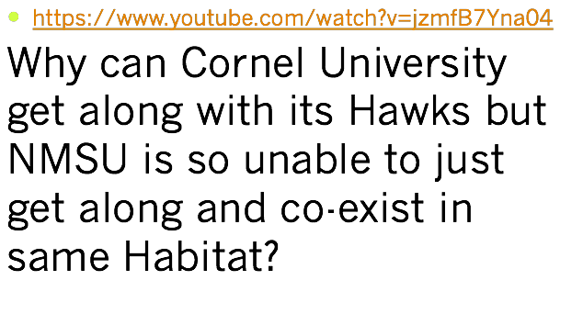
The answer to this important question can be understood in Hegel and Heidegger. There is a dialectic between what Heidegger calls fore-having (Hegel calls this and End that is "as it is in itself" that is not some extension of the instinct of Reason that is playing out some observer role as its Notion of end, see #257). In the fore-having kind of antenarrative the End is contingent and purposively related to an other. In this case fore-having of NMSU grounds operations Human doing nest destruction action, has its fore-having, as does the Hawk have its fore-having of nest site location, building nest, hatching fledgling and training them to fly. Both fore-having antenarratives immediately are, both are independent, and both fore-havings are mutually indifferent to one and other. The essence of their relation and the action of Human and Hawk respective meaning are different from each other. Both these fore-havings are different from the casual observer engaged in sense-making, either student walking to and from parking lot where nesting sites are located, where nests are being constructed, where nests are being destroyed, and so on. The sense-making-perception Hegel describes, at first finds the action of the Human de-nesting worker and the Hark action of nest builder, have something hidden. If instinct of Reason, the sensemaking/perception stays observing they can explore what is hidden from what at first is observed, and only shows itself in the End by the necessity in what takes place when the the two fore-having antenarratives are revealed to have been there from the very beginning, and the action of Human nest-destruction worker destroying nest sites, and Hawk pair building nest sites, has nothing else that issues froth from the action of other kinds of antenarrative, such as fore-structuring (between) or fore-conception (beneath) because only what fore-having is already there in its actions of its End for what is first (before) is the outcome of the antenarrative action of fore-having that returns to itself.
At Cornell there is not only fore-having as the essence of "as it is in itself" but the instinct of Reason, has fore-conception (beneath) and fore-structuring (between) antenarrative actions that arise out of the role of observer, and observer effects (as they are known in quantum storytelling). For Hegel "Reason is Spirit" (#468), can the instinct of Reason can arise in abstraction, in an initial superficial observer role, that does not get at what is hidden from sensemaking-perception.
At NMSU fore-having demonstrates itself to be something that has its own Self for its End and this is what Hegel calls a prius (#257), defined as something that is precedent, a Self, and the End arrives in the process of its fore-having action (before and first), the itself and in arriving this fore-having has "its feeling of self" (#257). Hegel ends section #257 by pointing out the dialectical distinction of fore-having (what Heidegger later calls it) "between what it is and what it seeks" but both aspects of the dialectical distinction are in its own self a Notion.
This is how the self-consciousness of the End (prius and before) is constituted "to distinguish itself from itself without producing any distinction" (Hegel, # 258). Hence the Human (de-nester worker) and the Hawk (nest builder) finds in their mutually indifferent "observation of organic Nature nothing else than a being of this kind" (#258). The Hawk has the instinct of a creature of the air who seeks and consumes food on the university lawns, finds dead twigs in university lawns to build a nesting the same tree site, year after year. The Hawk pair bring forth nothing other than itself as a couple, and their fledgling is the End of their fore-having. So to the Human grounds keepers, the workers with tools and machines, makes their observation of organic Nature as nothing else than what is fore Human kind, and fits themselves as a thing of Human life but makes a distinction of a Habitat that is fore Human only. The instinct of Reason in its quest at Cornell University, finds only Reason itself, in its acts and action of fore-structuring a connection or relation (between) Human and Hawk, and a fore-conception (beneath) that is one of awe and wonder, at the birth of the fledgling. Cornell University has prospered instinct of Reason that has gone beyond the kinds of sensemaking-perception of the signs posted around the NMSU campus:
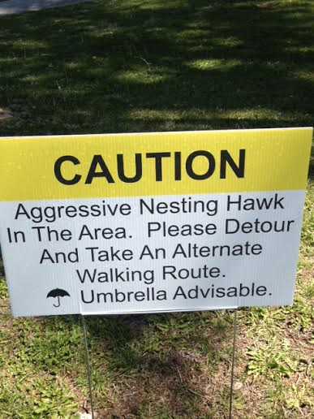
This Sign placed in the Frenger zone of the NMSU campus
This is an 'accusatory' rhetoric that Hawks are deficient in Human-best-practices. But we need forensic, and deliberative rhetoric, instead of this sort of inciting rhetoric. And we need posthumanist rhetoric of relationships of Hawk-Human-Habitat that is co-existence, cooperation, and respect.
But as science, enters into its instinct of Reason, and gets at the hidden beneath, it develops in its observation and experiments, at Cornell University, a quite different fore-conception of the Hawk and Human relationship.
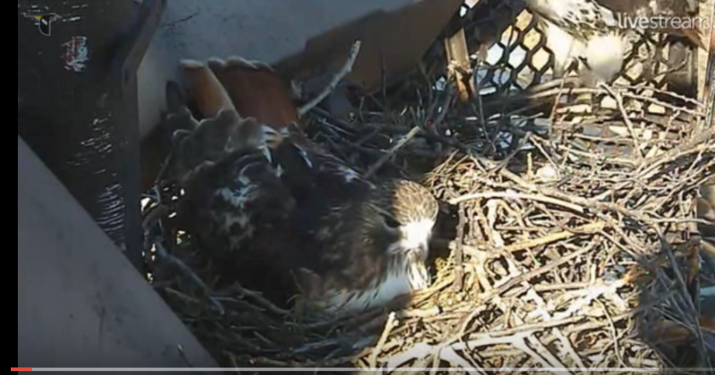
Cornell University Red Hawk nesting in Peace, in Changing of the guard, Momma Red Tail comes to relieve Papa Red Tail Hawk 03/21/2012 (from YouTubehttps://www.youtube.com/watch?v=jzmfB7Yna04).
Cornell in its fore-structuring (between) has build an Ornithology Lab, where its Science meets its Systems, in the interfusion of action and Being. This includes a web-cam for live streaming video of the pair of Hawks on Cornell's campus

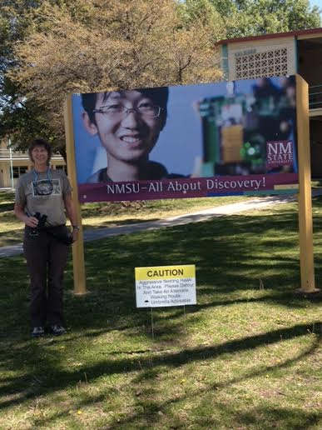
A photo of faculty member, Carol Campbell, in front to NMSU's 'All About Discovery!" official narrative, and the Operations Narrative: "CAUTION Aggressive Nesting Hawk in the Area. Please Detour and take an Alternate Walking Rout. Umbrella Advisable"
This strikes me as irony, the juxtaposition of Discovery at a Research University with operation Systems blaming the victim of daily removal of nesting sites as the culprit. To repeat, Slavoj Žižek (2014) question: "Is It Still Possible To Be A Hegelian Today?".
It is possible that Hegel had a very different Notion of dialectic than either Marx or Adorno. It is a dialectic of the instinct of Reason, finding something more than retrospective sensemaking, something hidden beneath, in the fore-structuring (between) Hawk-Human-Habitat.

References
Boje, D. M. (2014). Storytelling Organizational Practices: Managing in the Quantum Age. London/NY: Routledge
Boje, D. M. (2008). Storytelling Organizations. London: Sage.
Boje, D. M. (2011). Storytelling and the Future of Organizations: An Antenarrative Handbook (London: Routledge Studies in Management, Organizations and Society) [Hardcover]; Authors & Table of Contents
Boje, D. M. (2012a). Quantum Storytelling. Free book on line.
Boje, D. M. (2012b) Quantum Spirals for Business Consulting. Free book on line.
Boje, D. M., Svane, M., Henderson, T. L., & Strevel, H. B. (in press). Critical corporate social responsibility in tamara-land: The role of tetranormalizing fractals. In R. Ocler (Ed.), Book chapter for a Springer collection, Rodolphe Ocler (ed.).
Boje, M., & Svane, M., Gergerich, E. (in press). Counternarrative and Antenarrative Inquiry in Two Cross-Cultural Contexts. Cross Cultural Management.
Hegel's (1807) Phenomenology of Spirit, download from following links (or find your own copy elsewhere):
Attachment | Size
Phenomenology of Spirit - G. W. F. Hegel.epub | 638.7 KB
Phenomenology of Spirit - G. W. F. Hegel.mobi | 1.04 MB

Heidegger, M. (1962). Being and Time. Translated by John Macquarrie & Edward Robinson. NY: Harper Row. 1927 in German, 1962 English translation. see searchable text)
Theodor Adorno's Negative Dialectics Original German edition: Negative Dialektik, © 1966 by Suhrkamp Verlag, Frankfurt am Main English translation copyright © 1973 by Seabury Press, Incorporated First published in Great Britain in 1973 by Routledge & Kegan Paul Ltd Click here for PDF of book that is searchable
Walter Benjamin (selections from 1968 Illuminations book) Click here for online PDF (searchable)
The Storyteller Click here for PDF of chapter (searchable)
The Task of Translation Click here for PDF of chapter (searchable)
Work of Art in Age of Mechanical Reproduction (1935) Click here for PDF of chapter (searchable)
On the Concept of History Click here for pdf of chapter (searchable)
McCulloh, G. E. (2015). Toward an acoustic rhetoric: Vital materialism's diffractions (Doctoral dissertation, NEW MEXICO STATE UNIVERSITY).
Yuk-kwan Ng, R., & Höpfl, H. (2011). Objects in exile: the intimate structures of resistance and consolation. Journal of Organizational Change Management, 24(6), 751-766.
Svane, M., & Boje, D. (2014). Merger strategy, cross-cultural involvement and polyphony. Between Cultures and Paradigms, IACCM 2014, University of Warwick, UK. Conference Proceeding. To be published in: European Journal of Cross-Cultural Competence and Management.
Svane, M., & Boje, D.; Gergerich, Erika M. (2015). Counternarrative and Antenarrative Inquiry in Two Cross-Cultural Contexts. Accepted for publication in Special Issue on counternarrative, European Journal of Cross-Cultural Competence.
Svane, M., & Boje, D. (2015). Tamara land fractal change management - in between managerialist narrative and polyphonic living stories. Sc'Moi, Standing Conference for Management and Organizational Inquiry, Las Vegas.

